

# SUBMITTED TO: SUBMITTED BY:

DR. PARTISH PAUL Abhishek Singh Tomar

06015603119

B.Tech IV Sem Information Technology

# Dr. Akhilesh Das Gupta Institute of Technology & Management

**New Delhi – 110053**



INDEX

|  |  |  |  |
| --- | --- | --- | --- |
| **S.No** | **Name of the Program** | **Sign** | **Remarks** |
| 1. | To study the Potentiometer as an error detector. |  |  |
| 2. | To study the Synchro-Transmitter and Receiver. Also obtain output characteristics v/s input characteristics. |  |  |
| 3. | To plot speed-torque curves for AC servomotor for different voltages. |  |  |
| 4. | To obtain Pole-Zero plot of any transfer function using MATLAB. |  |  |
| 5. | To plot impulse, step and ramp response of a 2nd order system on same graph using MATLAB. |  |  |
| 6. | To study of PID controller for simulation process. |  |  |
| 7. | To study time response of simulated LTI system. |  |  |
| 8. | To plot root locus of 2nd order system using MATLAB. |  |  |
| 9. | To plot Nyquist Plot of LTI System Using MATLAB. |  |  |

# Experiment No: 01 POTENTIOMETER AS AN ERROR DETECTOR

**OBJECTIVE:** To study the Potentiometer as an error detector.

## APPARATUS REQUIRED:

|  |  |  |  |
| --- | --- | --- | --- |
| S. No. | Name of Apparatus | Range/Rating | Qty. |
| 1 | Potentiometer with DPM (Digital Panel Meter) Kit | Kit | 01 |
| 2 | AC Supply | 220 V, 50 Hz | 01 |
| 3 | Connecting Leads | --- | 03 |

**THEORY:**

A potentiometer informally a pot is a three-[terminal](http://en.wikipedia.org/wiki/Terminal_(electronics)) [resistor](http://en.wikipedia.org/wiki/Resistor) with a sliding contact that forms an adjustable [voltage divider.](http://en.wikipedia.org/wiki/Voltage_divider) If only two terminals are used, one end and the wiper, it acts as a variable resistor or rheostat. A [potentiometer measuring instrument](http://en.wikipedia.org/wiki/Potentiometer_(measuring_instrument)) is essentially a voltage divider used for measuring [electric potential](http://en.wikipedia.org/wiki/Electric_potential) (voltage); the component is an implementation of the same principle, hence its name.

Potentiometers are commonly used to control electrical devices such as volume controls on audio equipment. Potentiometers operated by a mechanism can be used as position [transducers,](http://en.wikipedia.org/wiki/Transducer) for example, in a [joystick](http://en.wikipedia.org/wiki/Joystick). Potentiometers are rarely used to directly control significant power (more than a [watt](http://en.wikipedia.org/wiki/Watt)), since the power dissipated in the potentiometer would be comparable to the power in the controlled load.

Potentiometers comprise a resistive element, a sliding contact (wiper) that moves along the element, making good electrical contact with one part of it, electrical terminals at each end of the element, a mechanism that moves the wiper from one end to the other, and a housing containing the element and wiper. The resistive element of inexpensive potentiometers is often made of [graphite](http://en.wikipedia.org/wiki/Graphite). Other materials used include resistance wire, carbon particles in plastic, and a ceramic/metal mixture called cermets. Conductive track potentiometers use conductive polymer resistor pastes that contain hard-wearing resins and polymers, solvents, and lubricant, in addition to the carbon that provides the conductive properties. Others are enclosed within the equipment and are intended to be adjusted to calibrate equipment during manufacture or repair, and not otherwise touched. They are usually physically much smaller than user-accessible potentiometers, and may need to be operated by a screwdriver rather than having a knob. They are usually called "preset potentiometers". Some presets are accessible by a small screwdriver poked through a hole in the case to allow servicing without dismantling. A [string potentiometer](http://en.wikipedia.org/wiki/String_potentiometer) is a multi-turn potentiometer operated by an attached reel of wire turning against a spring, enabling it to convert linear position to a variable resistance.

Potentiometers are rarely used to directly control significant amounts of power (more than a watt or so). Instead, they are used to adjust the level of analog signals (for example

[volume](http://en.wikipedia.org/wiki/Loudness) controls on [audio equipment](http://en.wikipedia.org/wiki/Audio_equipment)), and as control inputs for electronic circuits. For example, a light [dimmer](http://en.wikipedia.org/wiki/Dimmer) uses a potentiometer to control the switching of a [TRIAC](http://en.wikipedia.org/wiki/TRIAC) and so indirectly to control the brightness of lamps. Preset potentiometers are widely used

throughout electronics wherever adjustments must be made during manufacturing or servicing. User-actuated potentiometers are widely used as user controls, and may control a very wide variety of equipment functions. The widespread use of potentiometers in consumer electronics declined in the 1990s, with [rotary encoders,](http://en.wikipedia.org/wiki/Rotary_encoder) up/down [push-buttons](http://en.wikipedia.org/wiki/Push-button), and other digital controls now more common. However, they remain in many applications, such as volume controls and as position sensors.

## DIAGRAM:

Fig. Potentiometer as an Error Detector

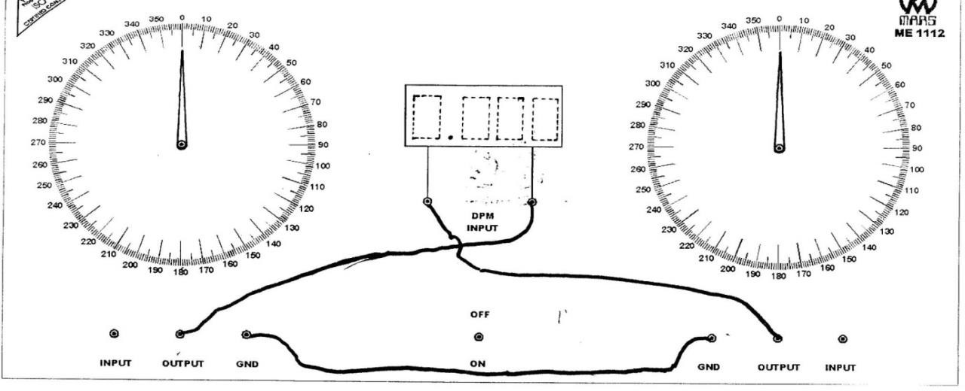

## PROCEDURE:

**Step 1:** Connect the leads in to the patch-cords of kit according to the circuit diagram. **Step 2:** Adjust the both Potentiometers through knob in this way, that the value of P1, P2 & DPM=0.

**Step 3:** Now give some movement like 30/45/60 degree in P1 knob. Note the value of AC Voltage. Now, increase P2 from 0 in such a way, that the value of DPM becomes 0.

**Step 4:** Note the angle of P2. Error is the difference between P1 & P2.

**Step 5:** Repeat the steps 3 & 4 at other angles up to 360 degree. Take 7-8 readings and fill up them in the following observation table.

## OBSERVATION TABLE:

|  |  |  |  |  |  |
| --- | --- | --- | --- | --- | --- |
| **S. No.** | **Pot. 1(P1)** | **DPM** | **Pot. 2(P2)** | **DPM** | **Error** |
| 1. | 0 | 0.00V | 0 | 0V | 0 |
| 2. | 20 | 0.021V | 21 | 0V | 1 |
| 3. | 30 | 0.032V | 31 | 0V | 1 |
| 4. | 40 | 0.043V | 41 | 0V | 1 |
| 5. | 60 | 0.064V | 62 | 0V | 2 |
| 6. | 80 | 0.083V | 81 | 0V | 1 |

**CALCULATION:**

*Mean Error = ∑ Errors*

*Total no. of errors*

= 0+1+1+1+2+1

6

*Mean Error* = 1

**RESULT:** Error between both potentiometers is obtained which are lies between 0-2 degrees.

## PRECAUTIONS:

1. Connection should be available according to the circuit diagram.
2. Connecting leads should be tight in the patch-cords of kit.
3. Take the readings carefully.

## QUESTIONS:

1. **Explain the working of potentiometer?**

Ans. Potentiometers work by varying the position of a sliding contact across a uniform resistance. It acts as an adjustable voltage divider.

## Write the application of potentiometer?

Ans. Potentiometers are commonly used to control electrical devices such as volume controls on audio equipment. Other applications include use in television to control picture brightness and use as position transducers.

## How Potentiometer is used as the Transducer?

Ans. As potentiometer give large output signals, they find applications in designing of displacement transducers. It is a resistive-type transducer that converts either linear or angular displacement into an output voltage by moving a sliding contact along the surface of a resistive element.

## State the Principle of a potentiometer.

Ans. The working principle depends on the potential across any portion of the wire which is directly proportional to the length of the wire that has a uniform cross-sectional area and current flow is constant.

## How can we increase the sensitivity of a potentiometer?

Ans. Sensitivity is defined as the smallest potential difference that is measured by using potentiometer. It can be increased by:

* 1. Increasing the length of the potentiometer wire.
  2. By reducing the current in the circuit by using a rheostat.

**EXPERIMENT NO: 02**

# SYNCHRO TRANSMITTER AND RECEIVER

**OBJECTIVE:** To study the Synchro-Transmitter and Receiver. Also obtain output characteristics v/s input characteristics.

## APPARATUS REQUIRED:

|  |  |  |  |
| --- | --- | --- | --- |
| S. No. | Name of Apparatus | Range/Rating | Qty. |
| 1. | Synchro-Transmitter and Receiver | Kit | 01 |
| 2. | AC Voltmeter | 0-300 V | 01 |
| 3. | AC Supply | 220 V, 50 Hz | 01 |
| 4. | Connecting leads | --- | 05 |

**THEORY:**

A transceiver is a device comprising both a transmitter and a receiver which are combined and share common circuitry or a single housing. When no circuitry is common between transmit and receive functions, the device is a transmitter-receiver. The term originated in the early 1920s. Technically, transceivers must combine a significant amount of the transmitter and receiver handling circuitry. Similar devices include transponder, transverter, and repeaters. Ours is a reputed entity prominently indulge in supplying and trading quality tested Transmitter & Receiver.

The offered products are specifically designed by the experts with the usage of ultra-modern technology and high-grade factor components. Owing to the salient features like low power consumption, easy operations, ability to withstand high temperatures and reassure and longer service life these transmitters & receiver are highly in conformance with the set industrial standards and can be availed in required specifications. There are only a few types of receiver and transmitter architectures. In a receiver, the central idea is to take information superimposed on an RF signal or carrier and convert it to a lower frequency form which can be directly applied to a speaker or digitized.

In a cellular communication system, the low-frequency signal, often called the baseband signal, could have a bandwidth of 30 kHz to 5 MHz and the carrier frequency could be 500 MHz to 2 GHz. A transmitter takes the baseband signal and superimposes it on an RF carrier which can be more easily radiated into space and propagates easily from one antenna to another. Their applications are Air traffic control, Guided missiles.

## C:\Users\MOHIT\Desktop\LAB\2015-04-09 mohit9-1\mohit9-1 001.jpgDIAGRAM:

Fig. Circuit Diagram of Synchro Transmitter & Receiver

## PROCEDURE:

**Step 1:** First of all, connect the leads in to the sockets of kit according to the circuit diagram.

**Step 2:** Adjust Transmitter and Receiver at zero position.

**Step 3:** Now give some movement like 30/45/60 degree in Transmitter knob. Receiver will also move then, record the movement angle of Receiver.

**Step 4:** Calculate the difference between angles of Transmitter and Receiver. Also note the A.C. voltages (V12, V23& V13) from the S1, S2, S3 stator sockets with the help of AC Voltmeter.

**Step 5:** Repeat the steps 3 & 4 at other angles up to 360 degree. Take 8-10 readings and fill up them in the following observation table.

## OBSERVATION TABLE:

|  |  |  |  |  |  |  |
| --- | --- | --- | --- | --- | --- | --- |
| **S. No.** | **Transmitter (Deg)** | **Receiver (Deg)** | **Error (Tx-Rx)** | **V1**  **2 (V)** | **V2**  **3 (V)** | **V1**  **3 (V)** |
| 1. | 30 | 31 | 1 | 5.75 | 5.45 | 0.296 |
| 2. | 40 | 41 | 1 | 5.17 | 5.94 | 0.763 |
| 3. | 50 | 51 | 1 | 4.52 | 6.26 | 1.728 |
| 4. | 60 | 62 | 2 | 3.40 | 6.47 | 3.06 |
| 5. | 70 | 71 | 1 | 2.43 | 6.40 | 3.98 |
| 6. | 80 | 80 | 0 | 1.118 | 6.06 | 4.95 |

**CALCULATIONS:**

*Mean Error = ∑ Errors Total no. of errors*

= 1+1+1+2+1+0

6

*Mean Error* = 1

**RESULT:** Error between Transmitter and Receiver is obtained which lie between 0-2 degrees.

## PRECAUTIONS:

* + 1. Connection should be available according to the circuit diagram.
    2. Connecting leads should be tight in the sockets of kit.
    3. Check the voltmeter which must be AC.
    4. Take the readings carefully.

## QUESTIONS:

1. **Explain the working of synchro – transmitter as transducer?**

Ans. The Synchro is a type of transducer which transforms the angular position of the shaft into an electric signal. It is used as an error detector and as a rotary position sensor**.** The transmitter and the control [transformer](https://circuitglobe.com/what-is-a-transformer.html) are the two main parts of the synchro. When the rotor is excited by ac voltage, the rotor current flows, and a magnetic field is produced. The rotor magnetic field induces an emf in the stator coils by [transformer](http://www.electricalengineeringinfo.com/2015/01/what-is-electrical-transformer-working-principle-of-transformer-construction-of-transformer.html) action. The effective voltage induced in any stator coil depends upon the angular position of the coil's axis with respect to the rotor axis.

## Write application of synchro – transmitter as transducer?

Ans. Synchros are used to transmit torque over a long distance without the use of a rigid mechanical connection. Fig. 39.18 represents an arrangement for maintaining alignment of two distantly-located shafts. The arrangement requires a control transmitter (CX) and a control receiver (CR) which acts as a torque receiver.

1. **Write the application of the synchro –transmitter and synchro-receiver as pair?** Ans. A Synchro system is formed by interconnection of the devices called the [Synchro Transmitter](https://www.pantechsolutions.net/control-system/synchro-transmitter-and-receiver) and the [synchro control transformer.](https://www.pantechsolutions.net/control-system/synchro-transmitter-and-receiver) They are also called as synchro pair. The synchro pair measures and compares two angular displacements and its output voltage is approximately linear with angular difference of the axis of both the shafts. They can be used in the following two ways.
2. To control the angular position of load from a remote place / long distance.
3. For automatic correction of changes due to disturbance in the angular position of the load.

## What is null position in synchro?

Ans. The zero position of the rotor is used as a reference for determining the rotor angular position. The output of the transmitter is given to stator winding of the control transformer.

## What are the various frequency domain specifications?

Ans. The frequency domain specifications are resonant peak, resonant frequency and bandwidth.

**EXPERIMENT NO: 03**

# A.C SERVOMETER

**OBJECTIVE:** To plot speed-torque curves for AC servomotor for different voltages.

## C:\Users\a\Desktop\5.PNGAPPARATUS REQUIRED:

**THEORY:**

An AC servomotor is basically a 2-phase induction motor except for certain design features. The two-phase induction motor consists of two stator windings oriented 90 0 electrical apart in space and excited by AC voltage which differ in time phase by 90 0. In fig.1, the schematic diagram for balanced operation of motor is shown where voltages of equal RMS magnitude and 90 0 phase difference are applied to the two-phase stator, thus making their respective field 900 apart in both time and space, resulting in magnetic field of constant

magnitude rotating at synchronous speed. The direction of rotation depends upon phase relationship of input voltage V1 and V2. As the field sweeps over the short-circuited rotor, voltages induced in it producing current in it. The rotating magnetic field interacts which these currents produce a torque on the rotor in the direction of field rotation.

The shapes of torque – speed characteristics of two-phase induction motor is shown in fig.2. The use of such motor (a) in control application is intolerable because of the positive slope which prevails over most of the operating speeds. The positive slope causes negative damping to lead instability in control system. In control applications the motor is modify in a way to ensure positive damping over full speed range. A convenient way to obtain the result shown in curve (b) is to design the motor with very high rotor resistance. Whenever the two phase induction motor is design with high rotor resistance it is referred as two-phase AC servomotor.

1. **The AC Servomotor Construction:** The motor used in this setup has the following spaces:
   1. Two phase AC servomotor ACM DT 15/120: E (rated) 120VAC/0.1Amp/phase.
   2. Phase split capacitor 1μF/440VAC.
   3. Rotor: Squirrel cage type diameter 15mm, soft diameter 5mm, speed 2500RPM/100V.

The coils with similar constructions (4no.) are wired / placed such the flux developed 900 electrically apart. Under a balanced condition, the winding is excited with equal voltage 900 apart in a time phase with the help of capacitor seriesed with one of the winding. The motor current therefore generates magnetic field in air gap which is also in a space and time quadrature. The rotating flux field induces a voltage in the rotor conductors with a magnitude propositional to the relative speed. A P pole, 50Hz winding cause the resultant field to rotate

at n rpm, and similar one at 400Hz will rotate at 8n rpm. The rotor voltage in turn causes currents as a result a torque is developed by interaction of current carrying conductor and rotating field. This drags the rotor along after the synchronous field of the stator. Since the rotor must overcome the friction, it cannot reach synchronous speed.

1. **About the Set-up:** The given AC servomotor is mounted and mechanically coupled with a small permanent magnet field DC motor for loading purpose. The AC servomotor is excited by step down isolated AC supply of 100V. The reference winding is connected through a phase split capacitor C, (1μF) with these voltages. The control winding is fed through a control P1 (provided upon the panel). A switch S1 is also provided to cut-off

the motor from the supply. A pair of sockets is given across the control winding to measure AC applied voltage (E). The DC motor when not connected with the provided DC supply (switch S2 is in OFF

condition) it generates speed proportional voltage across its terminals as back emf Eb. Another pair of sockets is given across the motor terminal for this measurement. When DC supply is fed to the DC motor it run in reverse direction of servomotor direction in result a load is imposed. The resultant toque developed by DC motor to overcome it increases the current through it which is indicated by panel meter. The expression used to

determine the developed torque is given

T (Torque) = P×1.019×10 4 ×60 gm-cm

2πN

Where P is the power Ia.Eb in watts, N is the speed in RPM. The speed is measured with the help of opto-interrupter transducer. A 6-hole disc is mounted upon the motor shaft to interrupt the light falling upon a photo diode which results in generating narrow pulse train, which is used to trigger a monoflop circuit. The width of the output pulses of monoflop is a subject of these trigger pulses repetition, which are rectified, averaged and fed to an analog meter calibrated in terms of RPM.

**CONNECTION DIAGRAM:**

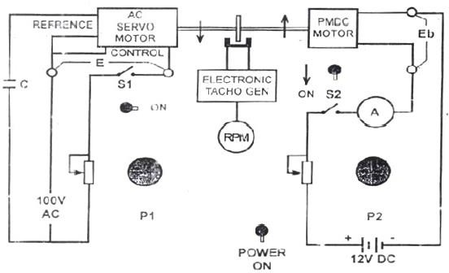

**PROCEDURE:**

1. Switch OFF the switches S1 and S2. Keep both controls P1 and P2 to minimum (fully counter-clockwise).
2. Switch ON the switch S1. Let S2 is in OFF position
3. Slowly increase control P1 so that AC servomotor start rotating.
4. Connect the digital multimeter (20V DC range) across the DC motor sockets given in RED and BLACK color.
5. Very the speed of servomotor gradually and note the speed N rpm from panel meter and corresponding back emf Eb developed across the DC motor.
6. Record the observation in table 1.
7. Connect the digital multimeter (range 200VAC) across the servomotor control winding sockets. Now adjust AC servo motor voltage to 80V AC, E1 = 80V. Note the speed rpm in table2.
8. Switch ON S2 to impose load upon the motor. The DC supply although at zero Volt but it short out the DC motor armature and fall in speed observed. Note the current Ia and speed from panel meters in steady state condition.
9. Increase the load current by means of control P2 in slow manner and note the corresponding speed and Ia in steady state condition. Record all the observations in table2.
10. Prepare table2, filling the Eb data from table1 for the corresponding speeds. Calculate P as P = Ia.Eb in watt. Calculate the torque as given in expression 1.
11. Adjust servomotor voltage to another value say E2 = 70VAC. Repeat the steps 7 – 10 and prepare another table. Prepare more tables for different E.
12. Draw speed – torque characteristics curves.

## OBSERVATION TABLE:

|  |  |  |
| --- | --- | --- |
| **S.No** | **Speed N(RPM)** | **Eb(Volts)** |
| 1) | 1600 | 2.4 |
| 2) | 1250 | 1.6 |
| 3) | 1000 | 1.2 |
| 4) | 750 | 0.9 |
| 5) | 500 | 0.6 |

|  |  |  |  |  |  |
| --- | --- | --- | --- | --- | --- |
| **S.No.** | **Ia(Amp)** | **Eb(tabl)** | **Speed N(RPM)** | **P(Watt)** | **Torque T** |
| 1) | 0.05 | 1.7 | 1300 | 0.085 | 6.365 |
| 2) | 0.07 | 1.2 | 1000 | 0.084 | 8.509 |
| 3) | 0.09 | 0.9 | 750 | 0.081 | 10.514 |
| 4) | 0.11 | 0.6 | 500 | 0.066 | 12.851 |
| 5) | 0.13 | 0.4 | 300 | 0.052 | 16.875 |

**CALCULATION:**

T (Torque) = P×1.019×104 ×60 gm-cm

2πN P (Power) = Eb ×Ia watts

## C:\Users\a\Desktop\7.PNGGRAPH:

**RESULT:**

Torque is always inversely proportional to the Speed i.e., T ∞ 1

N

## PRECAUTIONS:

1. Check the AC and DC voltmeters which should be at proper place.
2. Give small variation in P 1 and P 2.
3. Speed of motor should not be more than RPM meter.

## QUESTIONS:

1. **What is Servomotor? Give their classification in brief.**

Ans. A servo motor is a rotary actuator or a motor that allows for a precise control in terms of the angular position, acceleration, and velocity. Basically, it has certain capabilities that a regular motor does not have. Consequently, it makes use of a regular motor and pairs it with a sensor for position feedback.

Basically, servo motors are classified into AC and DC servo motors depending upon the nature of supply used for its operation.

## Explain the torque – speed characteristics of AC servomotor?

Ans. The torque speed characteristic of an ac servo motor is fairly linear and has negative slope throughout. The rotor construction is usually squirrel cage or drag cup type for an ac servo motor. The diameter is small compared to the length of the rotor which reduces inertia of the moving parts.

## On what factor does the direction of rotation of AC servomotor depend?

Ans. The direction of rotation of AC servo motor depends on the phase relationship of Input voltage V1 and V2.

## What is the drawback of AC servomotor?

Ans. i) Since the motor tries to rotate according to the command pulses, but lags behind. it is not suitable for precision control of rotation.

1. Higher cost.
2. When stopped, the motor's rotor continues to move back and forth one pulse. So that, it is not suitable if you need to prevent vibration.

## What is the phase relationship between reference voltage and control voltage?

Ans. The speed and torque of the rotor are controlled by the phase difference between the control voltage and the reference phase voltage. The phase relation between these two is 90 as there are displaced from each other at 90º.

**EXPERIMENT NO: 04 POLE-ZERO PLOTS**

**OBJECTIVE:** To obtain Pole-Zero plot of any transfer function using MATLAB.

**APPARATUS REQUIRED:** A PC with MATLAB installed in it.

**THEORY:** The transfer function provides a basis for determining important system response characteristics without solving the complete differential equation. As defined, the transfer function is a rational function in the complex variable s = σ + jω, that is

It is often convenient to factor the polynomials in the numerator and denominator, and to write the transfer function in terms of those factors:

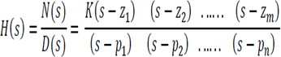(2)

Where the numerator and denominator polynomials, N(s) and D(s), have real coefficients

defined by the system’s differential equation and  As written in Eq. (2) the zi’s are the roots of the equation

N(s) = 0, (3)

and are defined to be the system zeros, and the pi’s are the roots of the equation

D(s) = 0, (4)

and are defined to be the system poles. In Eq. (2) the factors in the numerator and denominator are written so that when s = zi the numerator N(s) = 0 and the transfer function vanishes. Similarly, when s = pi the denominator polynomial D(s) = 0 and the value of the transfer function becomes unbounded.

All of the coefficients of polynomials N(s) and D(s) are real; therefore, the poles and zeros must be either purely real, or appear in complex conjugate pairs. The existence of a single complex pole without a corresponding conjugate pole would generate complex coefficients in the polynomial D(s). Similarly, the system zeros are either real or appear in complex conjugate pairs.

**PROGRAM:** Consider 1st order control systems whose close loop transfer functions are given as

G(s)= 

H(s)=

F(s)=

The pole zero plot of given systems can be obtained as follows:

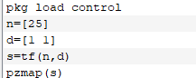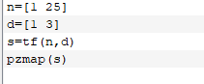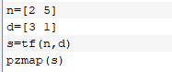

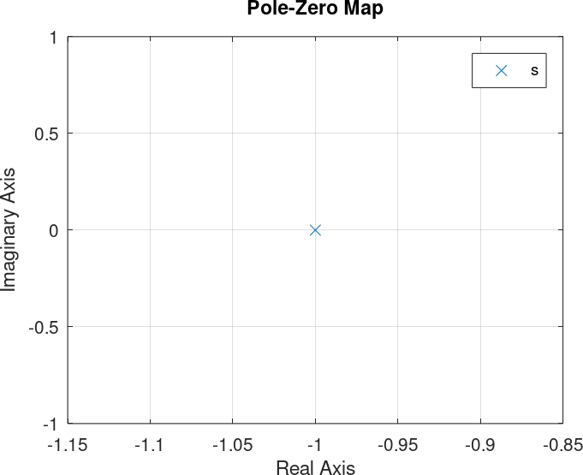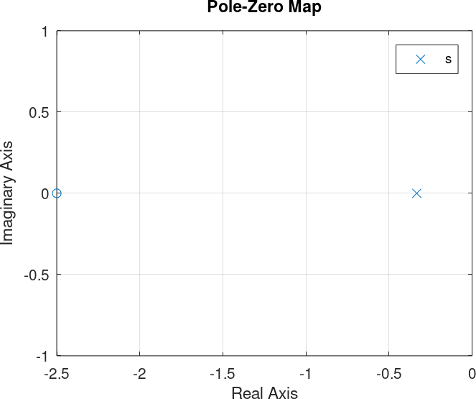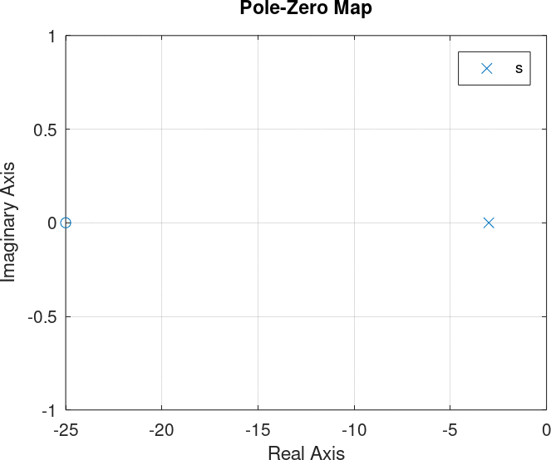**RESULT:** The pole-zero plot of the given transfer functions are obtained as given in below figures.

**PROGRAM:** Consider 2nd order control systems whose close loop transfer functions are given as

G(s)=

H(s)=

F(s)= 

The pole zero plot of given systems can be obtained as follows:

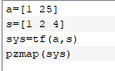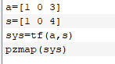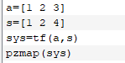

**RESULT:** The pole-zero plot of the given transfer functions are obtained as given in below figures.

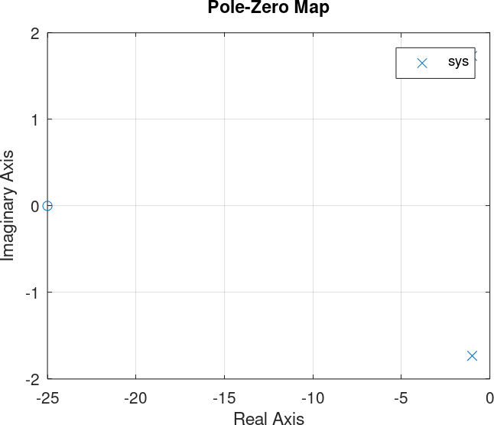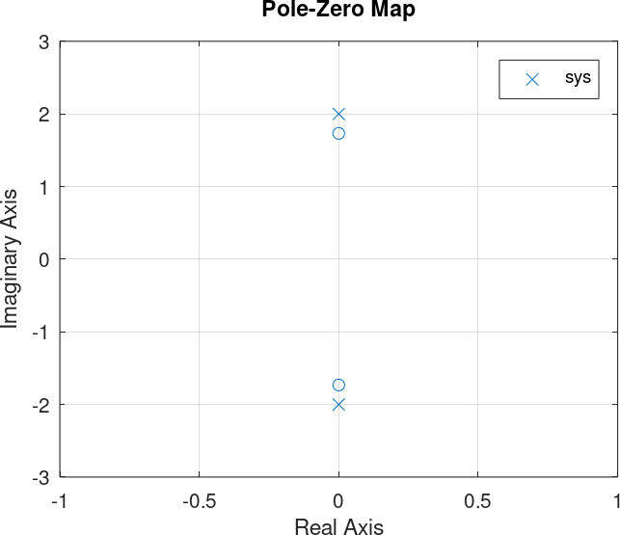

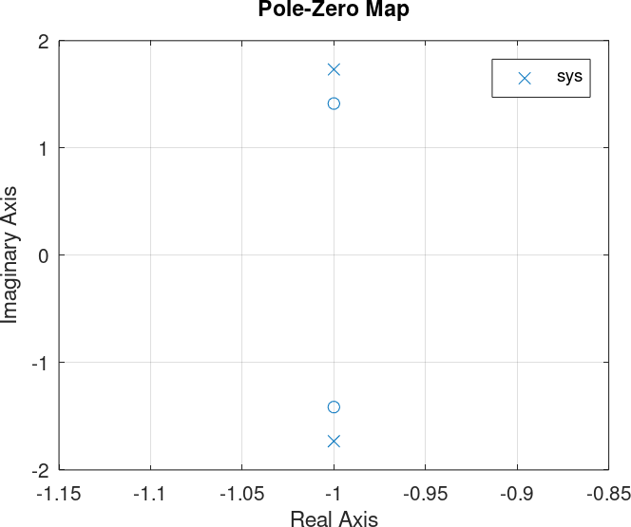

## PRECAUTION:

* 1. Adjust the axis dimension to view the plot properly.
  2. Adjust the size of pole zero symbols to proper size and color.
  3. Edit the font size of axis labels for better view.

## QUESTIONS:

1. **What is the significance of poles-zero analysis?**

Ans. Poles and Zeros of a transfer function are the frequencies for which the value of the denominator and numerator of transfer function becomes zero respectively. The values of the poles and the zeros of a system determine whether the system is stable, and how well the system performs. Control systems, in the simplest sense, can be designed simply by assigning specific values to the poles and zeros of the system.

## A linear system is described by the following differential equation: d2y/dt2 + 5dy/dt + 6y = 2 du/dt + 1

**Find the system’s poles and zeros.**

Ans. Poles: s= -3 and s= -2 & zero: s= -1/2

## Explain the effect of zeros on stability of system?

Ans. i) Root locus shift towards left half of the s-plane

* 1. system stability relatively increases
  2. system becomes less oscillatory in nature
  3. Range of operating values of K1 for stability of the system increases

## Explain the effect of poles on stability of system?

Ans. i) Root locus shift towards right half of the s-plane

1. system stability relatively decreases
2. system becomes more oscillatory in nature
3. range of operating values of k, for stability of the system decreases

**EXPERIMENT NO: 05 RESPONSE OF 2nd ORDER SYSTEM**

**OBJECTIVE:** To plot impulse, step and ramp response of a 2nd order system on same graph using MATLAB.

**APPARATUS REQUIRED:** A PC with MATLAB software installed in it.

**THEORY:** The time response of a system is the output of close loop control system as function of time. The response of system is usually divided in to two parts: the transient response and the steady state response. In control system, transient response is defined as the part which decays to zero as time becomes very large. The transient response is also called dynamic response of the system. The steady state response is simply that part of total response that remains after the transient has died out. The steady state can still vary in a fixed pattern such as sine wave or ramp function that increases with time.

The response of system is known as impulse response if the input applied to the system, is impulse signal. Similarly, if the inputs are step and ramp then output of control system is known as step response and ramp response respectively. The Nature of response of 2nd order system depends on damping ratio of the system. Depending upon the value of damping ratio, 2nd order system is characterized in four types: undamped, under damped, critically damped and over damped system. The response of a system can be obtained in MATLAB by following commands.

|  |  |
| --- | --- |
| **Command** | **Description** |
| Step | Plots step response of system |
| Step info | Gives step response specifications |
| Impulse | Plots impulse response of the system |

**PROGRAM:** Consider a 2nd order control system whose close loop transfer function is given as

*G*(*s*)  25

*s*2  3*s*  25

The response of the above system can be obtained as follows:

## Script: impulse response

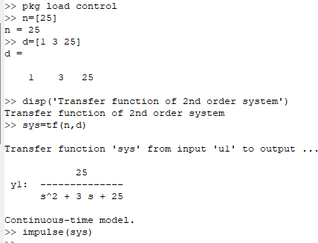

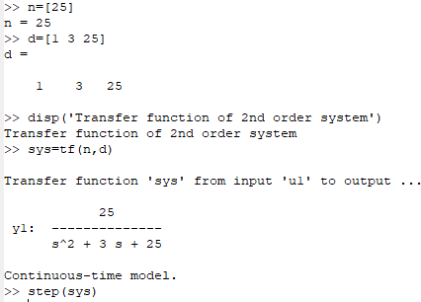**Script: step response**

**Script: ramp response**

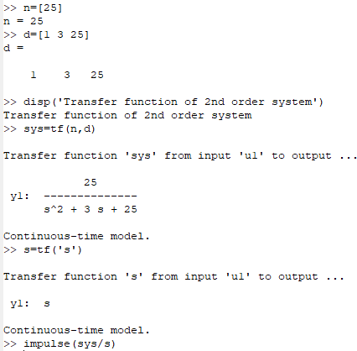

The above three scripts give the impulse, step and ramp response of the given system respectively on different graphs. For obtaining all three responses on same graph following script is used.

## Script: impulse, step and ramp response on same graph

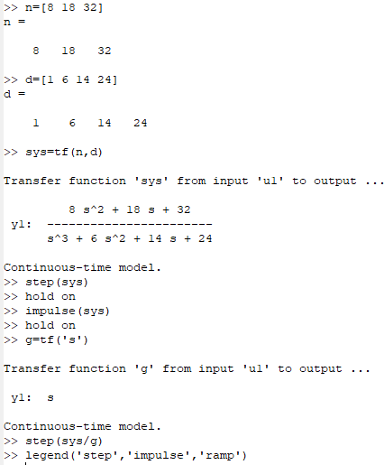

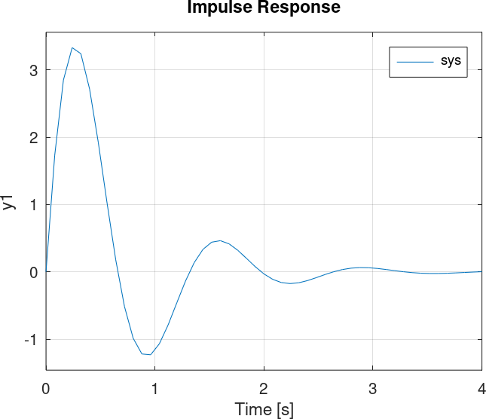**RESULT:** Impulse, step and ramp response of 2nd order control system has been plotted one by one on different graphs then all three responses has been plotted on a single graph.

Fig.1: Impulse Response of the System

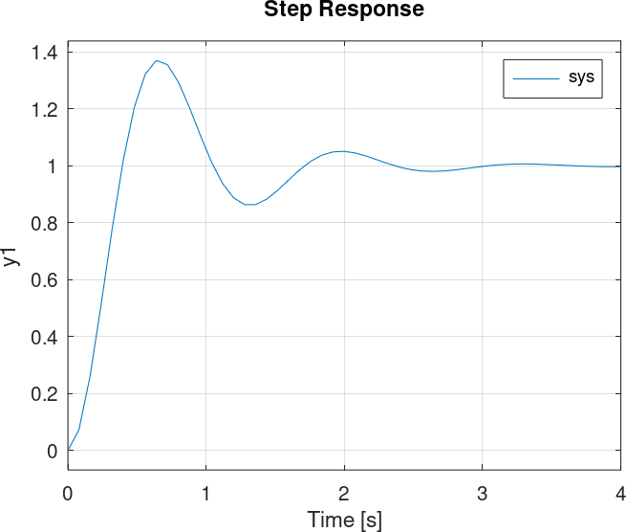

Fig.2: Step Response of the System

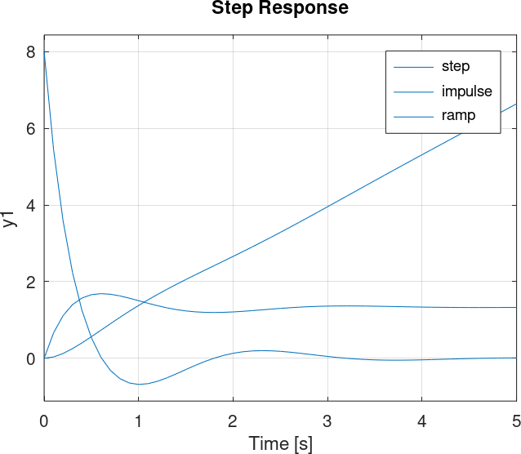

Fig.3: Response of 2nd order system

## PRECAUTION:

1. Adjust the axis dimension to view the plot properly.
2. View the plot with the grid.
3. Edit the font size of axis labels for better view.

## QUESTIONS:

1. **Function that is 0 everywhere except at t=0, where it is undefined is known as**
   1. **Unit step**
   2. **Unit ramp**
   3. **Unit impulse**
   4. **Singularity**

Ans. Unit impulse(C)

## For a Unit ramp function area of pulse curve is unity

* 1. **Discontinuous at time t=0**
  2. **Starts at time t=0 and linearly increases with t**
  3. **Both a and b**
  4. **None of the above**

Ans. Starts at time t=0 and linearly increases with t(B)

## In Unit impulse function

* 1. **Pulse width is zero**
  2. **Area of pulse curve is unity**
  3. **Height of pulse goes to infinity**
  4. **All of the above**

Ans. All of the above(D)

**EXPERIMENT NO: 06**

# PID CONTROLLER FOR SIMULATION PROCESS

**OBJECTIVE:** To study of PID controller for simulation process.

## APPARATUS REQUIRED:

|  |  |  |  |
| --- | --- | --- | --- |
| **S. No.** | **Name of Apparatus** | **Range/Rating** | **Qty.** |
| 1. | PID Controller | Kit | 01 |
| 2. | CRO | 20 MHz | 01 |
| 3. | AC Supply | 220 V, 50 Hz | 01 |
| 4. | Connecting leads | --- | 06 |

**THEORY:**

A proportional-integral-derivative controller (PID controller) is a generic [control loop](http://en.wikipedia.org/wiki/Control_loop) [feedback mechanism](http://en.wikipedia.org/wiki/Feedback_mechanism) ([controller](http://en.wikipedia.org/wiki/Controller_(control_theory))) widely used in [industrial control systems](http://en.wikipedia.org/wiki/Industrial_control_system). A PID controller calculates an "error" value as the difference between a measured [process variable](http://en.wikipedia.org/wiki/Process_variable) and a desired [set point.](http://en.wikipedia.org/wiki/Setpoint_(control_system)) The controller attempts to minimize the error by adjusting the process control inputs.

The PID controller calculation [algorithm](http://en.wikipedia.org/wiki/Algorithm) involves three separate constant parameters, and is accordingly sometimes called three-term control: the [proportional](http://en.wikipedia.org/wiki/Proportionality_(mathematics)), the [integral](http://en.wikipedia.org/wiki/Integral) and [derivative](http://en.wikipedia.org/wiki/Derivative) values, denoted P, I, and D. Simply put, these values can be interpreted in terms of time: P depends on the present error, I on the accumulation of past errors, and D is a prediction of future errors, based on current rate of change. The weighted sum of these three actions is used to adjust the process via a control element such as the position of a [control valve,](http://en.wikipedia.org/wiki/Control_valve) a [damper](http://en.wikipedia.org/wiki/Damper_(flow)), or the power supplied to a heating element.

In the absence of knowledge of the underlying process, a PID controller has historically been considered to be the best controller. By tuning the three parameters in the PID controller algorithm, the controller can provide control action designed for specific process requirements. The response of the controller can be described in terms of the responsiveness of the controller to an error, the degree to which the controller [overshoots](http://en.wikipedia.org/wiki/Overshoot_(signal)) the set point, and the degree of system oscillation. Note that the use of the PID algorithm for control does not guarantee [optimal control](http://en.wikipedia.org/wiki/Optimal_control) of the system or system stability.

Some applications may require using only one or two actions to provide the appropriate system control. This is achieved by setting the other parameters to zero. A PID controller will be called a PI, PD, P or I controller in the absence of the respective control actions. PI controllers are fairly common, since derivative action is sensitive to measurement noise, whereas the absence of an integral term may prevent the system from reaching its target value due to the control action.

## C:\Users\MOHIT\Desktop\LAB\2015-04-09 MOHIT9-3\MOHIT9-3 001.jpgCONNECTION DIAGRAM:

Fig.1: PID Controller

## PROCEDURE:

**Step 1:** Connect the leads in to the sockets of kit & CRO according to the circuit diagram.

**Step 2:** First of all, apply square wave form as a step input to the PID controller. **Step 3:** Trace the process output waveforms of P, I & D from CRO after simulation. **Step 4:** Now, apply triangular wave form as a step input to the PID controller.

**Step 5:** Trace the process output waveforms of P, I & D from CRO after simulation.

**RESULT:** We have studied the PID controller properly for plant simulation process.

## PRECAUTIONS:

* + 1. Connection should be available according to the circuit diagram.
    2. Connecting leads should be tight in the sockets of kit.
    3. Trace the waveforms from CRO on trace paper only.

## QUESTIONS:

1. **The input of a controller is**
   1. **sensed signal**
   2. **Error signals**
   3. **desired variable value**
   4. **Signal of fixed amplitude not dependent on desired variable value**

Ans. (b) Error signals

## Explain the following terms in a controller?

* 1. **Measurement variable:** A measurement variable is an unknown attribute that measures a particular entity and can take one or more values. It is commonly used for scientific research purposes. Unlike in mathematics, measurement variables can not only take quantitative values but can also take qualitative values in statistics. A process variable, process value or measurement variable is

the current measured value of a particular part of a process which is being monitored or controlled.

* 1. **Desired variable:** The desired position is called the setpoint (SP). The difference between the PV (Process Variable) and SP is the error (e), which quantifies whether the arm is too low or too high and by how much.
  2. **Deviation:** The control deviation (difference between reference percentage and actual percentage) is signaled to the PID controller. The PID controller adjusts the output frequency of the variable frequency drive such that the control deviation is minimized.
  3. **Output:** The input to the process (the electric current in the motor) is the output from the PID controller. It is called either the manipulated variable (MV) or the control variable (CV).

## What is a controller? Where are its application areas?

Ans. A controller is an instrument used for controlling a process variable (measurement). Its continuously monitors the error signal and gives a corrective output

to the final control element. The term PID stands for proportional integral derivative and it is one kind of device used to control different process variables like pressure, flow, temperature, and speed in industrial applications. In this controller, a control loop feedback device is used to regulate all the process variables. This type of control is used to drive a system in the direction of an objective location otherwise level.

The PID controller applications include the following:

* Temperature Control of Furnace
* MPPT Charge Controller
* The Converter of Power Electronics
* PID Controller Interfacing

## Explain what is the ‘direct action’ and ‘reverse action’ on a controller?

Ans. Direct action means that the controller output rises if the measurement increases. Indirect (reverse) action means that the controller output drops when the measurement rises. For example, it depends on the placement of the control valve in the case of a tank level control. If the valve controls the flow out of the tank, we would like to see a positive error (tank level high) in order to increase the control output, open the valve and leave more fluid out of the tank. However, if the valve controls the flow into the tank, a reverse - acting controller would be used to respond to a high level by closing the valve and reducing the flow into the vessel.

## What is the gain? Write the relation in between a gain and proportional band?

Ans. Proportional band is defined as the amount of change in the controlled variable required to drive the loop output from 0 to 100%. Gain is the ratio of output change (%) over the measured variable change (%) that caused it*.*

In a PID controller, the PB (Proportional Band) is the inverse of the Gain.

PB = 100 / Gain

or

**EXPERIMENT NO: 07**

# TIME RESPONSE OF SIMULATED LTI SYSTEM

**OBJECTIVE:** To study time response of simulated LTI system.

**APPARATUS REQUIRED:** A PC with MATLAB Installed in it.

**THEORY:** The defining properties of any LTI system are linearity and time invariance. Linearity means that the relationship between the input and the output of the system is a [linear](https://en.wikipedia.org/wiki/Linear_map) [map](https://en.wikipedia.org/wiki/Linear_map): If input x1(t) produces response y1(t) and input x2(t) produces response y2(t) then the scaled and summed input ax1(t)+bx2(t) produces the scaled and summed response ay1(t)+by2(t) where ‘a’ and ‘b’ are real [scalars.](https://en.wikipedia.org/wiki/Scalar_(mathematics))

Time invariance means that whether we apply an input to the system now or T seconds from now, the output will be identical except for a time delay of T seconds. That is, if the output due to input x(t) is y(t), then the output due to input x(t-T) is y(t-T). Hence, the system is time invariant because the output does not depend on the particular time the input is applied.

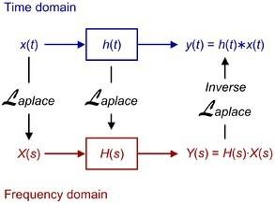

The fundamental result in LTI system theory is that any LTI system can be characterized entirely by a single function called the system's [impulse response.](https://en.wikipedia.org/wiki/Impulse_response) The output of the system is simply the [convolution](https://en.wikipedia.org/wiki/Convolution) of the input to the system with the system's impulse response. This method of analysis is often called the [time domain](https://en.wikipedia.org/wiki/Time_domain) point-of-view. In frequency domain LTI system is defined by transfer function which is Laplace transform of impulse response of the system. As a result of the properties Laplace transforms, the output of the system in the frequency domain is the product of the transfer function and the transform of the input. In other words, convolution in the time domain is equivalent to multiplication in the frequency domain. The same result is true of discrete-time linear shift-invariant systems in which signals are discrete-time samples, and convolution is defined on sequences.

## C:\Users\Student\Documents\simulation.PNGSIMULATION:

Fig.1:

Simulation of LTI system

**RESULT**: LTI System was simulated in MATALB/Simulink. Impulse and Step Response of simulated system is shown in figures below.

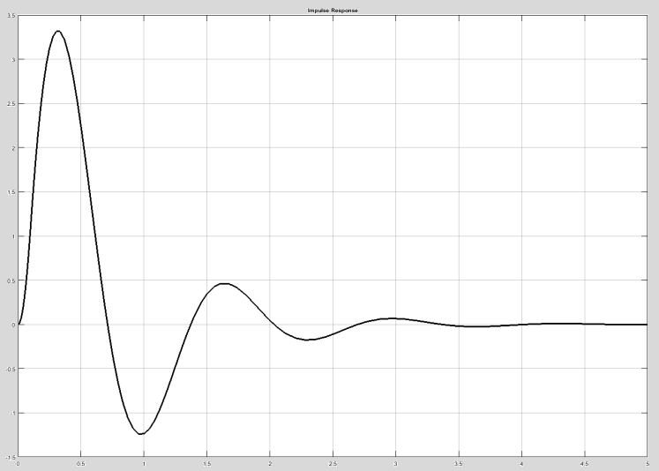

Fig.2: Impulse Response of Simulated System

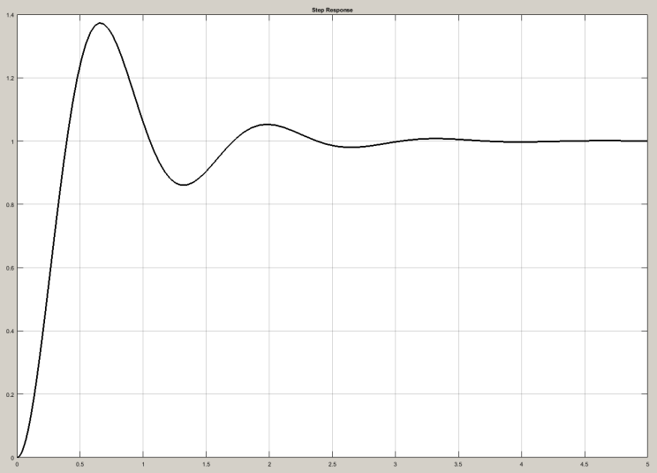

Fig.3: Step Response of Simulated System

## PRECAUTION:

1. Adjust the axis label’s font size to view the axis values clearly.
2. View the plot with the grid.
3. Edit the figure properties for proper color and size of waveform lines.

## QUESTIONS:

1. **What is the rule h*(x+y) = (y+x)*h called a) Commutatively rule**

**b) Associativity rule c) Distributive rule d) Transitive rule**

Ans. a) Commutatively rule because by definition, the commutative rule h*x=x*h.

## What is the following expression equal to: h*(c*(b+d(t))), d(t) is the delta function?

1. **h*c + h*b b) h*c*b + b c) h*c*b + h*c d) h*c*b + h**

Ans. c) h*c*b+h*c. Apply commutative and associative rules.

## The system transfer function and the input if exchanged will still give the same response a) True

1. **False**

Ans. a) True because by definition, the commutative rule h*x=x*h=y. Thus, the response will be the same.

**EXPERIMENT NO: 08**

# ROOT LOCUS PLOT OF 2nd ORDER SYSTEM

**OBJECTIVE:** To plot root locus of 2nd order system using MATLAB.

**APPARATUS REQUIRED:** A PC with MATLAB software installed in it.

**THEORY:** The transfer function can be displayed graphically in the s-plane or z-plane by means of a pole zero map. In general, the location of close loop poles in the s-plane or z-plane changes as the open-loop gain factor K is varied. Root locus is an analytical method for displaying the location of the poles of the closed-loop transfer function as a function of the gain factor K of the open loop transfer function. The locus of these roots plotted in the s-plane or z-plane as a function of K is called a root-locus. As gain K is increased from zero to infinity, the loci of the close loop poles originate from the open- loop poles and terminate at the open-loop zeros. This method requires that only the location of the poles and zeros of open loop transfer function to be known, and does not require factorization of the characteristic polynomial. Root-locus techniques permit accurate computation of the time-domain response in addition to yielding readily available frequency response information. Root Locus can be plotted in MATLAB with the help of command given below.

|  |  |
| --- | --- |
| **Command** | **Description** |
| rlocus() | Plots root locus of control system |

**PROGRAM:** Consider a 2nd order control system whose open loop transfer function is given as

G(s)  25

s2 3s 25

The root locus of the above system can be plotted in MATLAB using script given below:

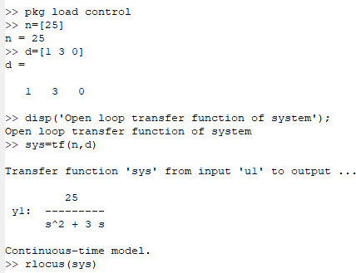***Script: Root locus***

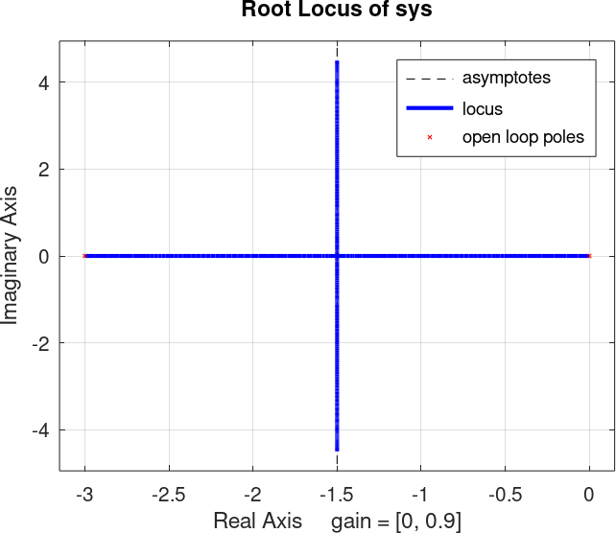**RESULT:** The root locus for 2nd order system has been plotted.

Fig.1: Root Locus Plot

## PRECAUTION:

* 1. Adjust the axis dimension to view the plot properly.
  2. View the plot with the grid.
  3. Edit the font size of axis labels for better view.

## QUESTIONS:

1. **Solve the practical example of root locus by taking the above transfer function. Ans. Required transfer function:**

**G(s)= 200 s4 + 8s3 + 36s2 + 80s**

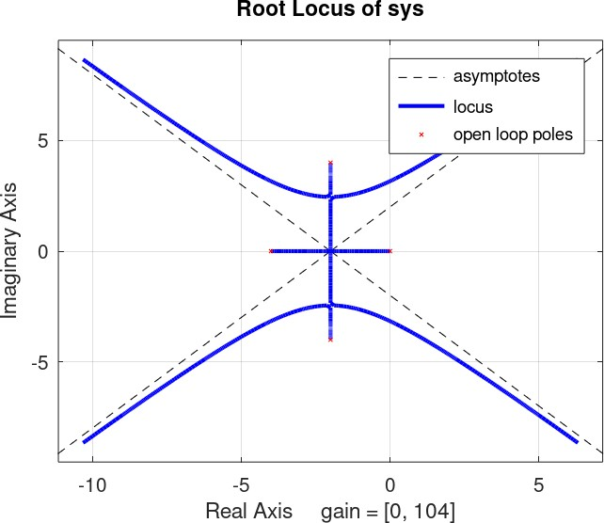

1. **Consider the loop transfer function K(s+6)/(s+3) (s+5) in the root locus diagram the centroid will be located at:**

**a) -4 b) -1**

**c) -2 d) -3**

Ans. c) -2

## Which one of the following applications software’s is used to obtain an accurate root locus for?

**a) LISP b) MATLAB**

## c) dBase d) Oracle

Ans. b) MATLAB

## Which one of the following is not the property of root loci?

1. **The root locus is symmetrical about imaginary axis**
2. **They start from the open loop poles and terminate at the open loop zeroes**
3. **The breakaway points are determined from dK/ds = 0**
4. **Segments of the real axis are the part of the root locus if and only is the total number of real poles and zeroes to their right is odd.**

Ans. a) The root locus is symmetrical about imaginary axis.

## If the gain of the system is reduced to a zero value, the roots of the system in the s- plane,

1. **Coincide with zero**
2. **Move away from zero**
3. **Move away from poles**
4. **Coincide with the poles**

Ans. d) Coincide with the poles

## The addition of open loop zero pulls the root loci towards:

1. **The left and therefore system becomes more stable**
2. **The right and therefore system becomes unstable**
3. **Imaginary axis and therefore system becomes marginally stable**
4. **The left and therefore system becomes unstable**

Ans. a) The left and therefore system becomes more stable

## When the number of poles is equal to the number of zeroes, how many branches of root locus tends towards infinity?

**a) 1 b) 2**

## c) 0 d) equal to number of zeroes

Ans. c) 0

**EXPERIMENT NO: 08**

# NYQUIST PLOT OF 2nd ORDER SYSTEM

**OBJECTIVE:** To plot Nyquist Plot of LTI System Using MATLAB.

**APPARATUS REQUIRED:** A PC with MATLAB Installed in it.

**THEORY:** A Nyquist plot is an alternative way of representing the frequency response characteristics. It uses Cartesian coordinates in two dimensions whose ordinate represents the imaginary axis and abscissa represents the real axis. A specific value of frequency defines a point on the table with Im[G(jw)] as ordinate and Re[G(jw)] as abscissa. The distance vector of the point from origin has the magnitude √(Re[G(jw)])2 + (Im[G(jw)])2 which is equal to the amplitude ratio and the angle set by this vector with the real axis is phase shift. The following figure is an example of Nyquist plot for first order process. We can use MATLAB to make Nyquist plots using the command **nyquist(G)**. Information about the plots obtained with this command can be found by left-clicking the mouse on the curve. You can find the curve's label, as well as the coordinates of the point on which you have clicked and the frequency.

Right-clicking away from a curve brings up a menu. From this menu, you can select

1. System responses to be displayed (with and without negative frequencies)
2. Characteristics, such as peak response and stability margins. When selected, a dot appears on the curve at the appropriate point. Let your mouse rest on the point to read the value of the characteristic.
3. Select the frequency units in Hz.
4. Set axis limits and grid.

## PROGRAM:

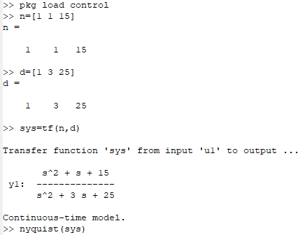

**RESULT:** Nyquist plot of given system is found to be as shown in below figure.

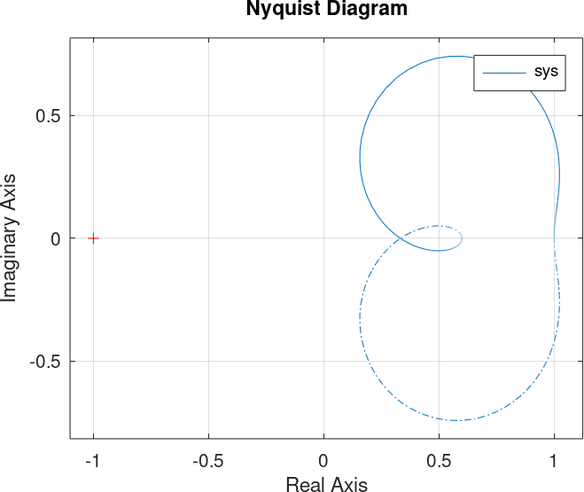

## PRECAUTION:

* 1. Axis range should be manipulated for proper view of Nyquist plot.
  2. Before saving the plot, make sure all encirclements are visible and can be counted.
  3. For better view of circles axis dimensions should be made equal.

## QUESTIONS:

1. **For Nyquist contour, the size of radius is**

d) ∞

c) 1

b) 0

a) 25

Ans. d) ∞

## According to Nyquist stability criterion, where should be the position of all zeros of q(s) corresponding to s-plane?

d) Random

c) On right half

b) At the center

a) On left half

Ans. a) On left half

## Nyquist criterion helps in

* 1. **Transmitting the signal without ISI**
  2. **Reduction in transmission bandwidth**
  3. **Increase in transmission bandwidth**
  4. **Both a) and b)**

Ans. d) Both a) and b)

## The difficulty in achieving the Nyquist criterion for system design is

* 1. **There are abrupt transitions obtained at edges of the bands**
  2. **Bandwidth criterion is not easily achieved**
  3. **Filters are not available**
  4. **None of the above**

Ans. a) There are abrupt transitions obtained at edges of the bands